**Establish and Manage Azure SQL DB service**

We should have a **Azure Subscription**.

Under that we should create a **Resource Group**.

Under that Resource Group , we can have **different types of Resources** as given below,

* **SQL Server**
* **DB Schema** (we can have multiple schemas based on the requirement)
* **Key Vault** - To store the credentials of different types of resources
* **Log Analytics** - We can check and analyse the logs of DB
* **Storage Account** - we need to create the storage account. This account provides File and Blob storage services to store the logs in the form of xel

We have to get one of the following roles to log in Azure Portal to monitor and manage the different types of the resources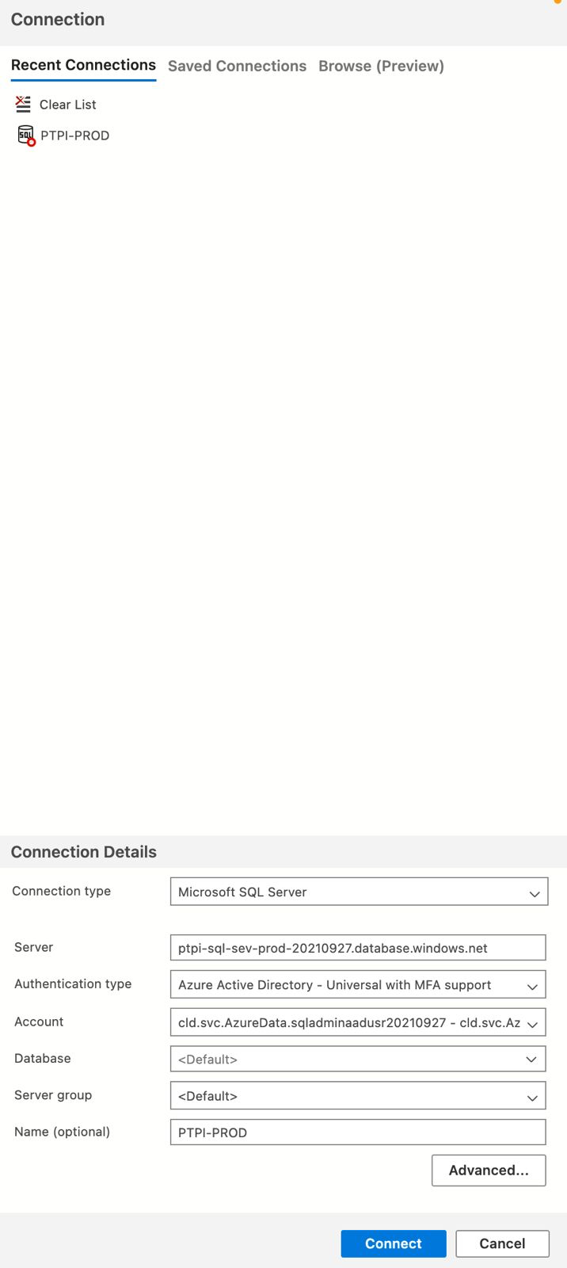

Roles

* **Reader**
* **Contributor**

To get the contributor role, we have to raise **Privileged Identity Management** (PIM) request

**Azure Data Studio** is used to connect the Azure SQL DB Schema. It is like a client in the local environment to connect the DB server and the specific DB schema.

Using the **Contributor Role**, we have to do the following steps to access DB server and Schema from the local machine.

* We need to add a firewall rule at server level
* We need to whitelist our IP address (Just add our IP address displayed in the Azure Portal)

We have two types of user credentials to connect as well as manage the DB schema from Azure YAML based pipeline and also the Microservices deployed in Azure-PCF cloud environment.

PCF AAD User - This credential is used to connect the DB schema from the Applications/Microservices deployed in Azure-PCF cloud environment.

SQL Admin AAD User - This credential is used to Manage DB schema through Azure YAML pipeline for the managing reset of password of the PCF AAD user credential.

* Reset Password Pipeline **(Azure YAML based pipeline)** will be run monthly as cron job
* Create a temp user credentials and update the same to the **CredHub** of the applications deployed in the different CFs on Azure Cloud
* And then **Re-stage the applications One by One in different CFs** to make sure that the applications use the new temporary credentials to connect to Azure SQL DB
* Reset the password of the actual PCF AAD User
* Store the **password updated PCF AAD User credentials** in **KeyVault**
* And then update the same (with new password) to **CredHub** of the applications deployed in the different CFs on Azure Cloud
* And then Re-stage the applications One by One in different CFs to make sure that the applications start using the latest PCF AAD User credentials (with new password) to connect to Azure SQL DB

Note:

**Connections are made at DB server level, not at the DB schema level**

**Purchase Models**

Azure SQL Database offers several purchasing models to cater to different workload characteristics and budget constraints. The following are the different models it offers,

1. **DTU-based Model**: In this model, you select a service tier based on a combination of compute, storage, and IO resources measured in Database Transaction Units (DTUs). DTUs are a blended measure of CPU, memory, and read/write rates. This model is suitable for most general-purpose workloads where predictable performance is needed.
2. **vCore-based Model**: This model offers greater flexibility by allowing you to select the number of vCores (virtual cores) and the amount of memory independently. You can also configure the amount of storage needed. It is suitable for scenarios where you need precise control over compute resources and want to optimise costs for specific workload characteristics.
3. **Serverless Compute**: Azure SQL Database also offers a serverless compute option where you pay for compute resources used per second. With this model, you don't need to provision or manage compute resources explicitly, and the database automatically pauses during periods of inactivity, reducing costs. It's ideal for unpredictable or intermittent workloads.
4. **Hyperscale**: This is a specialised configuration designed for large databases that require high scalability and performance. Hyperscale can automatically scale storage up to 100 TB, and it provides high throughput and rapid scaling of compute resources. It's suitable for data warehousing, large-scale analytics, and scenarios where massive data volumes are involved.

Each of these models has its advantages and is suited to different scenarios. When choosing a purchasing model, consider factors such as workload characteristics, performance requirements, scalability needs, and budget constraints.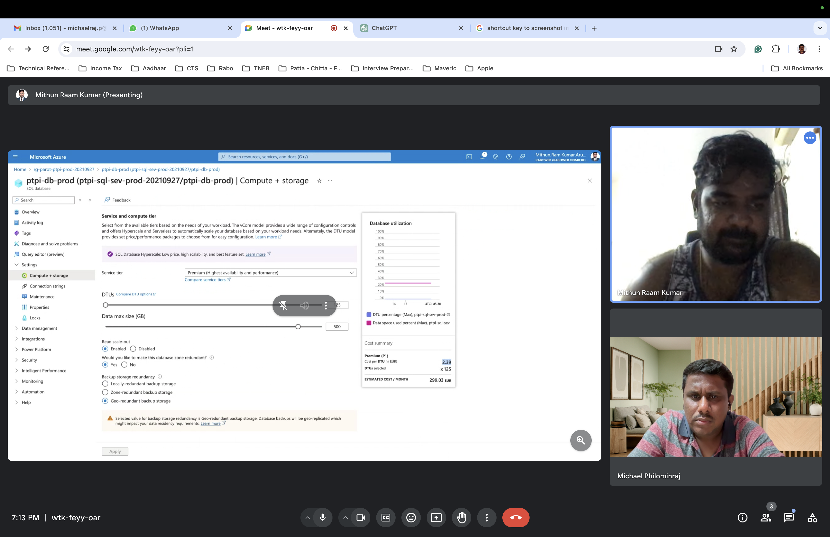

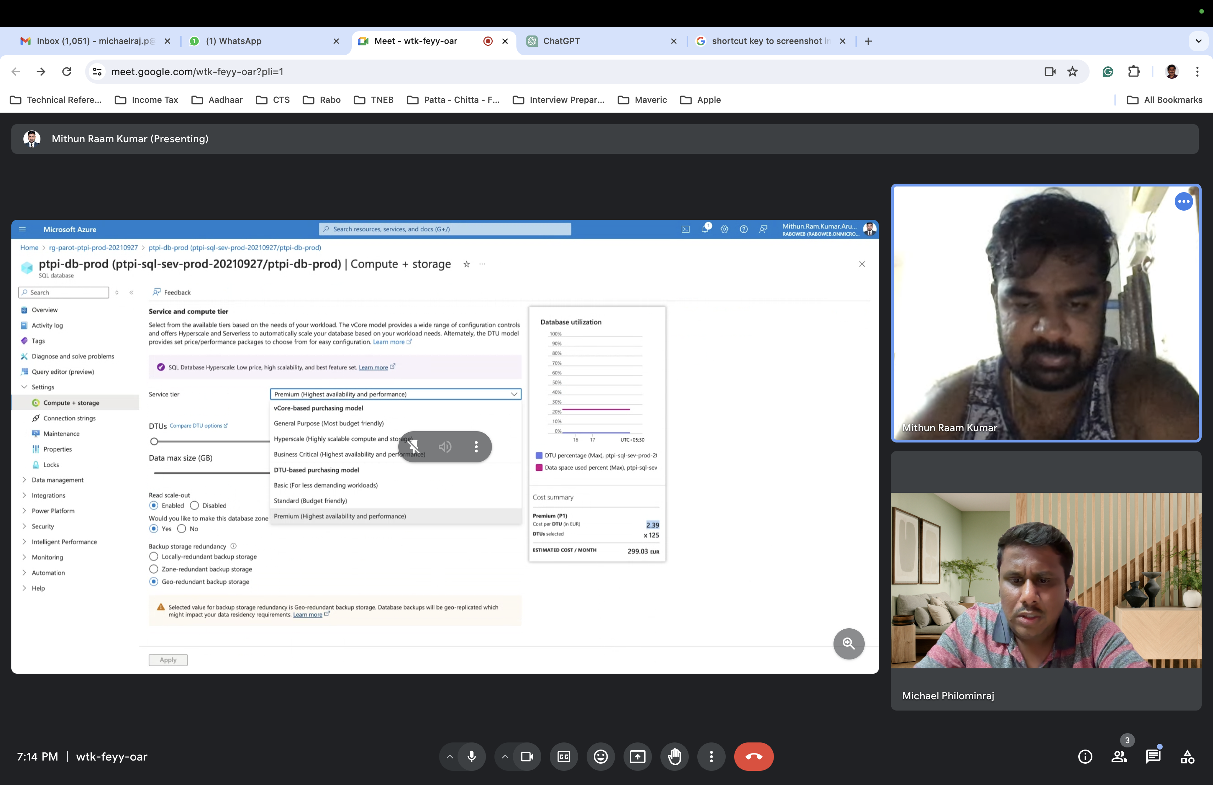

Azure provides pricing calculators and guidance to help you choose the most cost-effective option for your specific use case.

* The **vCore-based purchasing model** is available for both [Azure SQL Database](https://learn.microsoft.com/en-us/azure/azure-sql/database/service-tiers-vcore?view=azuresql) and [Azure SQL Managed Instance](https://learn.microsoft.com/en-us/azure/azure-sql/managed-instance/service-tiers-managed-instance-vcore?view=azuresql).
* The **DTU-based purchasing model** is available for [Azure SQL Database](https://learn.microsoft.com/en-us/azure/azure-sql/database/service-tiers-dtu?view=azuresql).

**Monitoring**

Alerts - we can set the alert on the cost with a limit to receive the notification emails

Metrics - Different types of metrics like CPU Utilisation Percentage, Data IO Percentile, DTU Percentile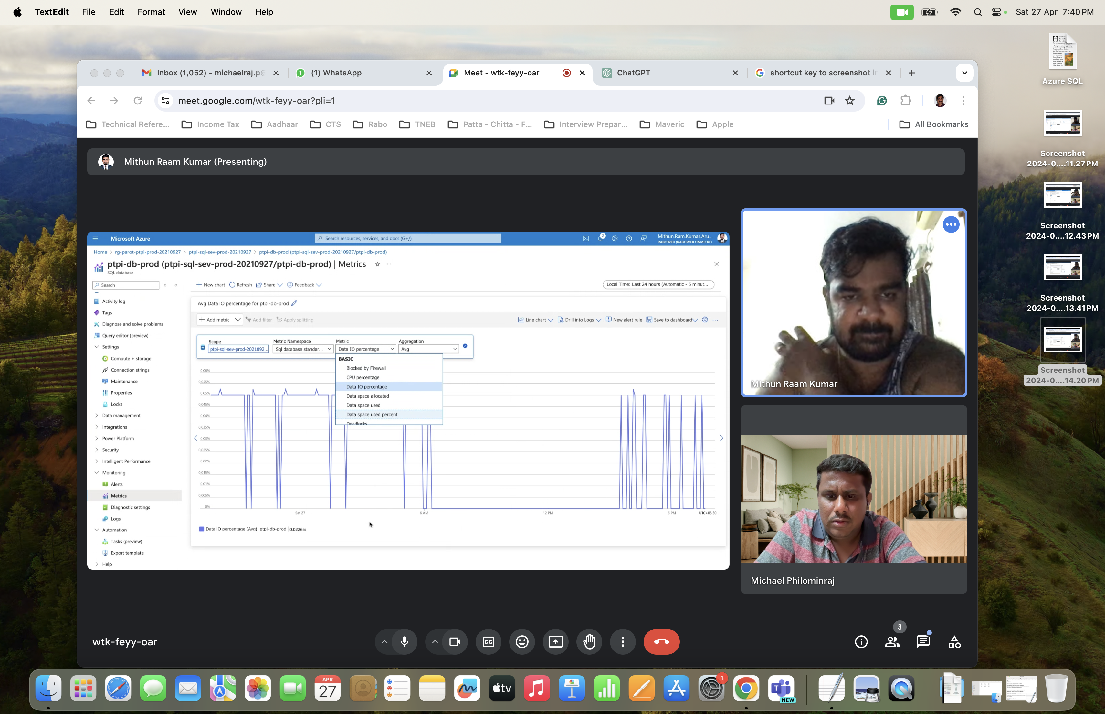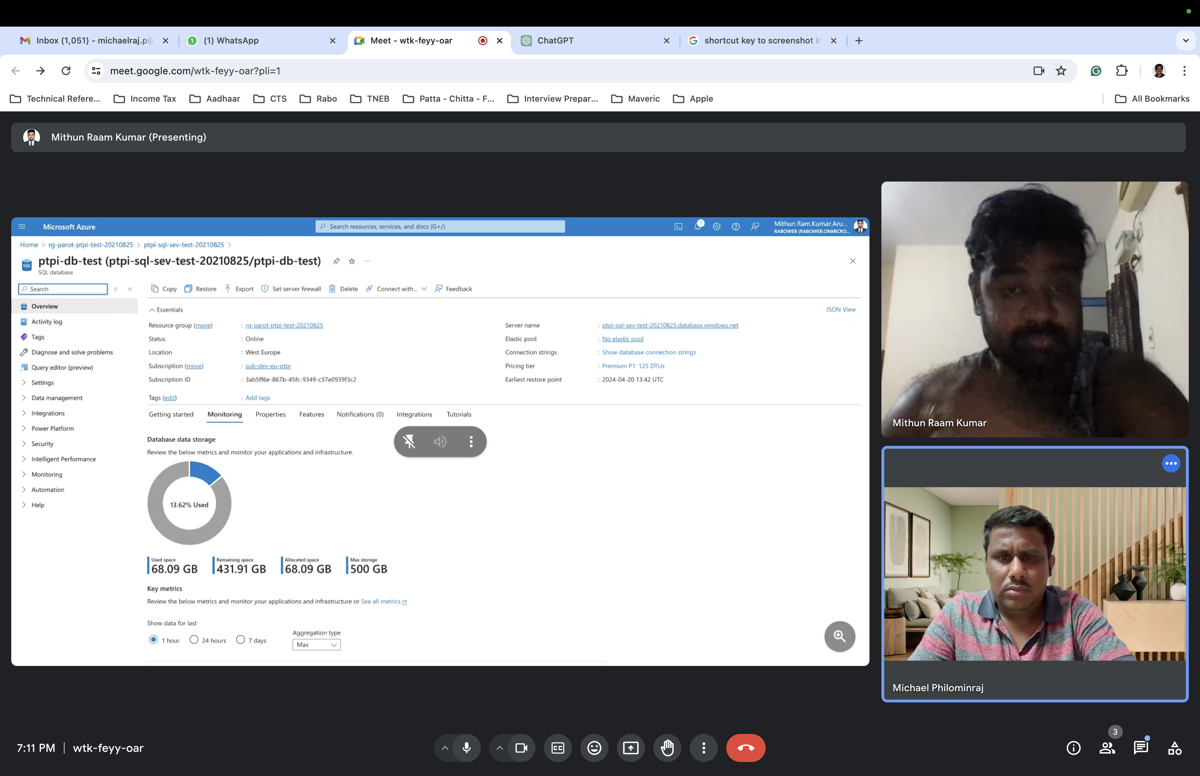

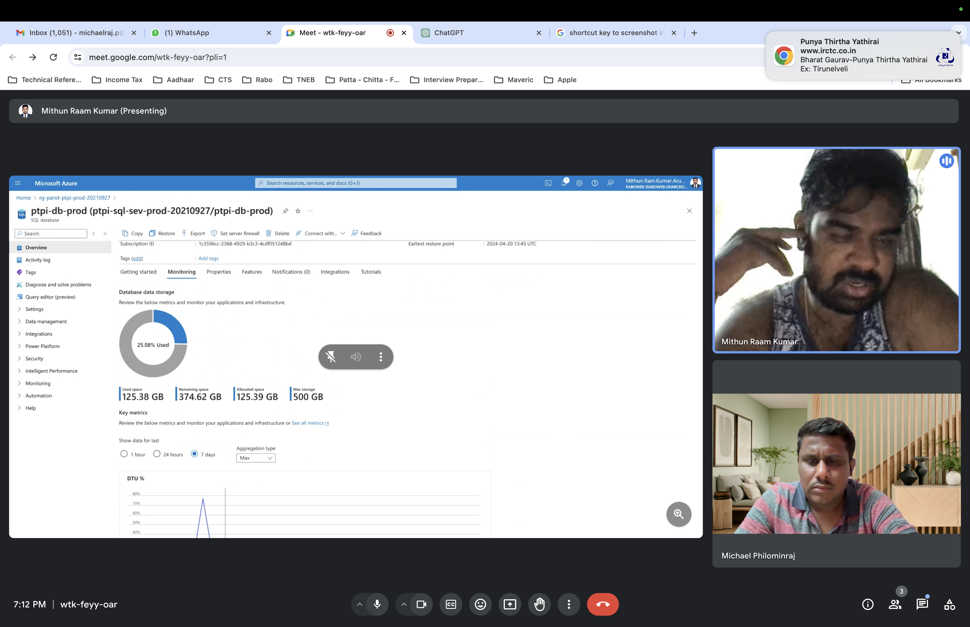

Logs - we can check different types of logs

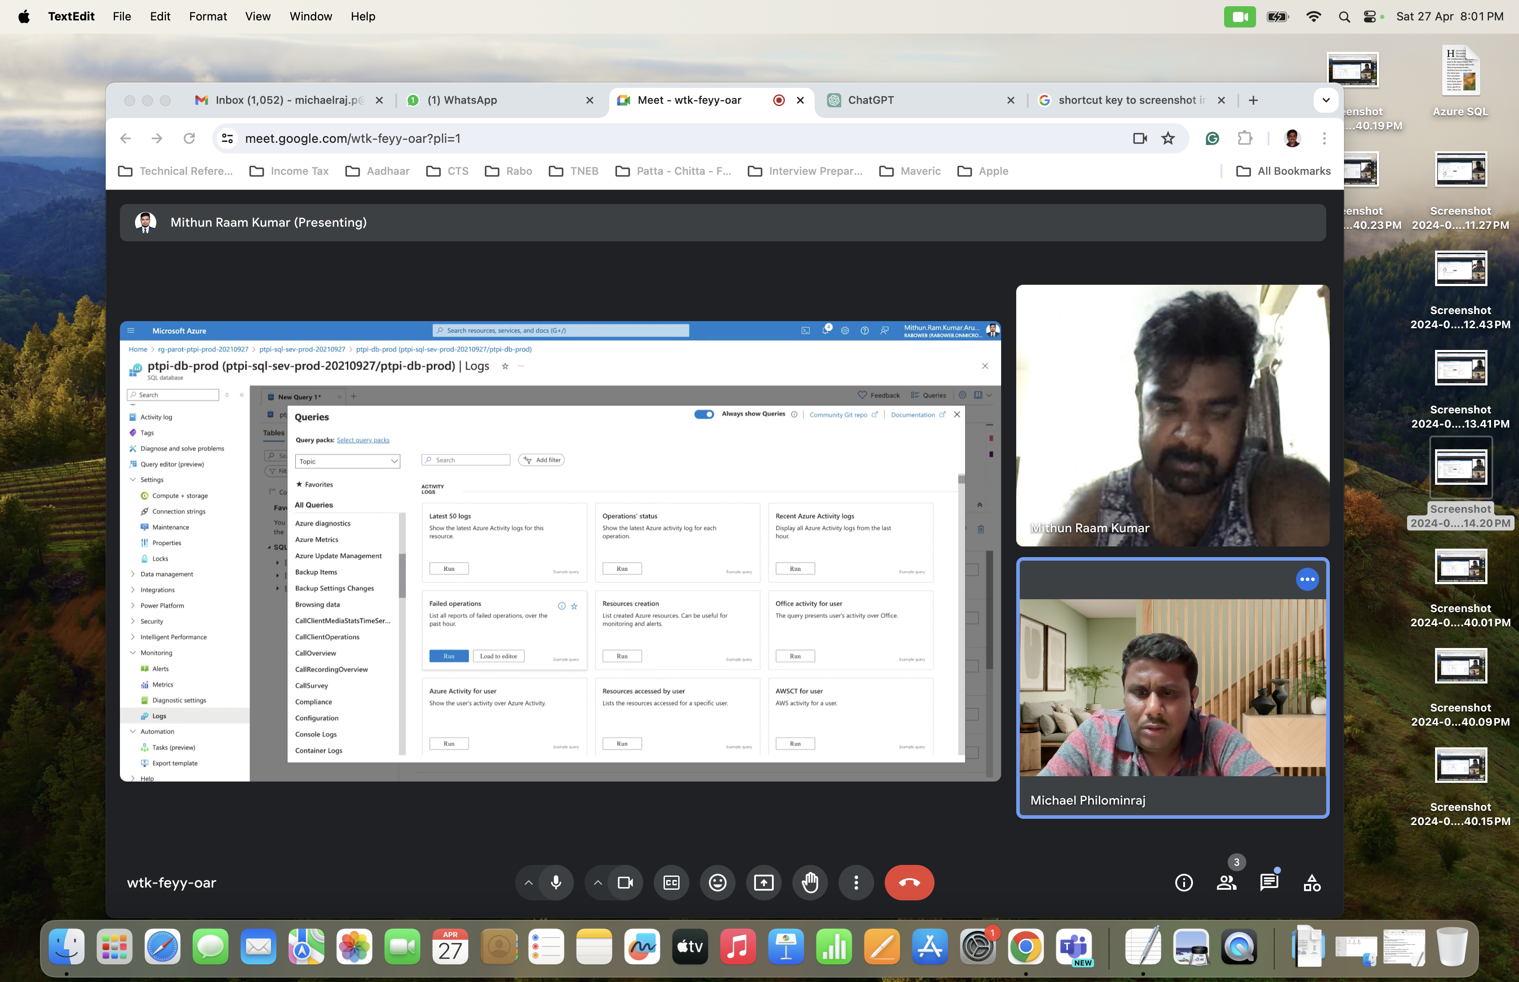

Data Migration

- Get Access to Jump and Production VM where DB is located in DMZ

- Configure the firewall for Outbound requests towards Azure Portal

- Create and configure Azure Data Factory pipeline

- As part of this configuration , install SHIR - Self Host Integration Runtime

- SHIR will act as an agent in VM in DMZ to connect to Oracle DB

* ADF pipeline on the other side will connect to target DB , i.e. Azure SQL DB

Refer the following links

<https://learn.microsoft.com/en-us/azure/data-factory/tutorial-hybrid-copy-data-tool>

<https://marlonribunal.com/copy-data-from-on-premise-sql-server-to-azure-database-using-azure-data-factory/>

<https://medium.com/@ruwansriw/copy-data-from-an-on-premises-sql-server-database-to-azure-blob-storage-using-azure-data-factory-ce3b3255b7d6>